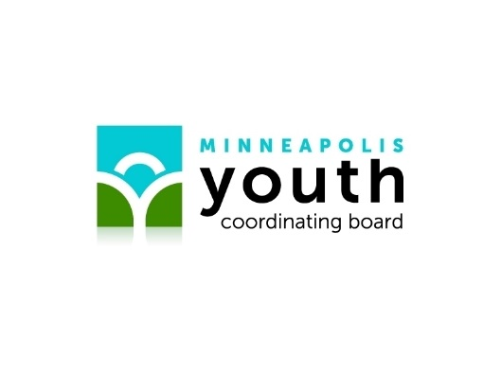
MISSION, VISION, THEORY OF CHANGE, VALUES, PRIORITIES, GOALS AND STRATEGIES

Mission – describes the core functions of the Minneapolis Youth Coordinating Board. Our mission is to champion the health, safety, education and development of Minneapolis’ children and young people through collective action and policy alignment.

Vision – guides future development, operations and maintenance of the Minneapolis Youth Coordinating Board in other words, what we hope to become. Our vision is Minneapolis is a richly diverse city where every child is cherished, every talent nurtured, and every voice respected; where no child or youth is hungry, homeless, hurting or afraid; where children, youth and families are celebrated and supported; where youth and adults treasure what they offer to one another; and where young people grow to enrich their community now and into the future.

Theory of Change – how we expect to reach a commonly understood long-term goal.
We mobilize children and young people, while supporting adults to share power, to shape cultures and systems. We do this so that young people can empower their education, have their safety prioritized, be connected to the natural and social world, and engage in their communities.

Values – describes how we approach our work and interact with children, young people, and public and private partners. We value –
1) Equity and justice recognizes the meaningfulness of forces such as race, gender, ethnicity, socioeconomic status, sexuality, and all their intersections, and confronts forces and institutions that marginalize youth on these grounds.
2) Public jurisdictions must make every attempt to provide stability for young people, including meeting basic needs and ensuring social and emotional supports.
3) Though youth and children are resilient by nature, we must provide them with the resources, community, and support necessary to fully actualize their resilience and promote healing.
4) We encourage and support collaboration and alignment of strategies across jurisdictional lines.

Priorities - The priorities structure the Youth Master Plan by bringing our values to life and articulating directions for change over the next five years. We prioritize -
1. Youth agency: Youth are active agents in shaping their futures through youth-adult partnerships that recognize and value youth ownership and leadership within their communities.
a. Power of knowledge speaks to the disempowerment youth feel among adults in the community as they fail to recognize and value youths’ experiential knowledge.
2. Culturally responsive approaches: Acknowledges that race, ethnicity, age, socioeconomic status, and all their intersections are foundational to one’s identity, honors their meaningfulness to the individual and community, and the importance of cultural resilience.
a. Identity seeks to ensure that youth are confident in their racial/ethnic identity, develop positive racial/ethnic identify, are free from all forms of discrimination and gaps
3. Gender and sexuality inclusivity: Gender and sexuality inclusivity acknowledges the foundational nature of gender and sexuality to one’s identity and prioritizes the safety and inclusion of female, nonbinary, and LGBTQ+ youth.
a. Female safety ensures that female-identifying and female-coded youth, including trans youth, feel safe in their communities.
b. Sex education advocates for consent-based sex education and increased resources.
4. Social connection: Young people must have supportive community, supportive relationships, and a say in building and contributing to their communities.
a. Unity seeks to ensure that youth have access to strong community ties.
5. Supportive systems: We must advocate for systems and institutions that promote youth development through collaboration and aligning strategies and break down and reform systems that hinder youth development.
a. Community improvements advocates for park and recreation activities, built environment, and public art that are inclusive and accessible to all youth.
b. Climate literacy seeks to increase to environmentally friendly practices and increase the accessibility of alternate forms of transportation.
c. School improvements supports increasing school-based systems for support, making the curriculum more diverse and relevant to youths’ experiences, and expanding opportunities to access resources.
6. Developmental needs: Children and youth must live in safe, stable environments in which their needs, both for survival and for social, political, and economic advancement, are met to grow and thrive in directions that are personally fulfilling and enrich their communities.
a. Accessible necessities seek to secure basic needs for youth in Minneapolis, including opportunity and economic stability.
b. Community safety addresses the lack of preventative resources for youth involved in violence and the need for increasing protective factors against, such as jobs and community services for youth.
c. Public health necessities address the lack of mental health advocacy and awareness, the inaccessibility of affordable healthcare, and substance abuse.

Goals – What we plan to accomplish in the next 5 years.
Will come out of the recommendations. But they currently are:
- All Minneapolis children enter kindergarten ready to be successful in school.
- All Minneapolis young people graduate from High School on time.
- All Minneapolis young people have access to safe, quality opportunities to learn outside of the classroom.
- All Minneapolis children and young people will build the grit, curiosity, and character to be contributing citizens and residents engaged in furthering their education, career and civic life.

Strategies – Provide us with guidance on how to accomplish the goals.
The Minneapolis Youth Coordinating Board is an intermediary organization - we support the provision of services by other organizations rather than providing direct services ourselves. Our strategies include:
• Convening the partners & facilitate youth and community involvement in the process;
• Collaborating to establish vision, goals & strategies, & increase collective effectiveness;
• Champion policy issues, leadership and action to benefit young people;
• Communicating progress, issues to be addressed & outcome indicators; and
• Creating new pilot programs, information resources & tools beyond the scope of the individual partners.

